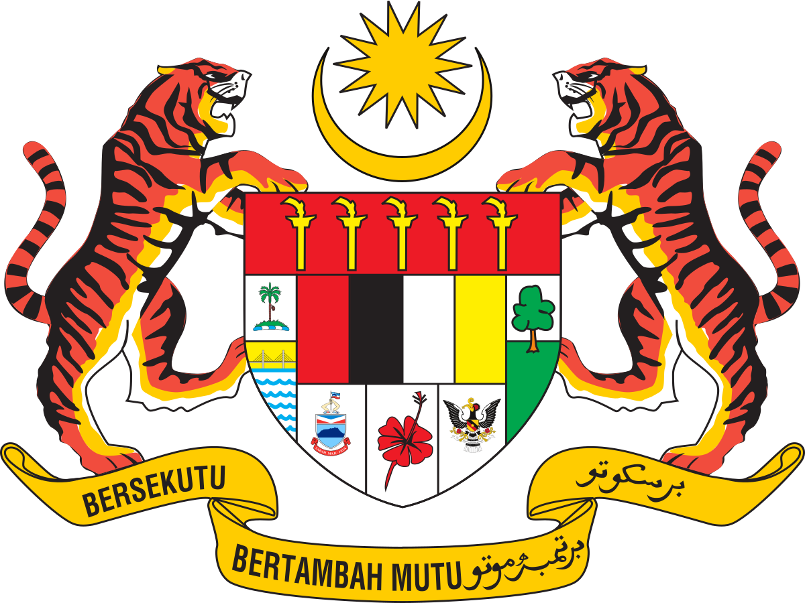Prime Minister as the head of the Government

in Malaysia

The power of the prime minister is subject to a number of limitations. Prime ministers removed as leader of his or her party, or whose government loses a vote of no confidence in the House of Representatives, must advise a new election of the lower house or resign the office. The defeat of a supply bill (one that concerns the spending of money) or unable to pass important policy-related legislation is seen to require the resignation of the government or dissolution of Parliament, much like a non-confidence vote, since a government that cannot spend money is hamstrung, also called loss of supply.

Conclusion

* Mahathir worked hard to serve his country from the day he took his role of prime minister.
* He created a concept called VISION 2020 that means he had a plan to see Malaysia as a fully developed country within 2020.
* Based on trading and industrialization Mahathir made Malaysia developed.
* Mahathir successfully handled all the financial crisis including crisis of 1997 and stabilized the Malaysian economy.

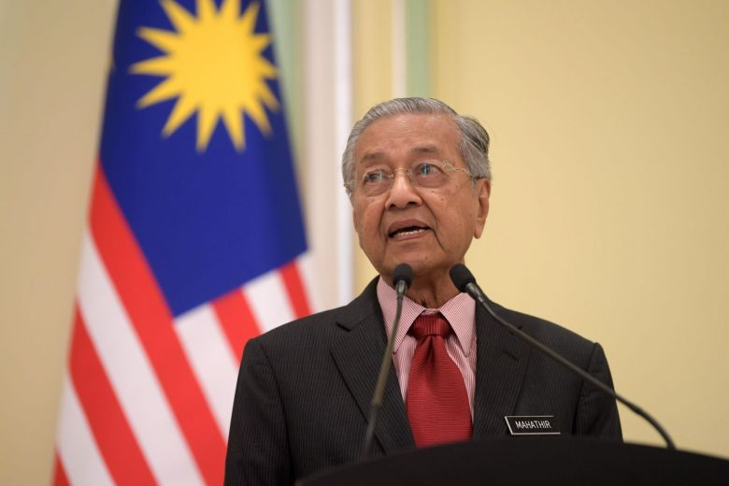

Contribution

A prime minister is the head of a cabinet and the leader of the ministers in the executive branch of government, often in a parliamentary or semi presidential system. In many systems, the prime minister selects and may dismiss other members of the cabinet, and allocates posts to members within the government.

Responsibilities

* Has responsibility to maintain unity in the cabinet and provide direction to ministers
* Make responsible government possible
* Makes collective responsibilities real
* Responsible for monitoring the implementation of the Government program and assisting the ministers in the general management of Government activities.

Election in Malaysia exist at two levels : federal level and state level .Federal level elections are those for membership in the Dewan Rakyat ,the lower house of parliament, while state level elections are for membership in the various State Legislative Assemblies. The heads of executive branch at both the federal and state level the prime minister and chief minister respectively, are indirectly elected, usually filled by a member of the majority party in the respectively legislatures. In 2018 Malaysia elected Mahathir Bin Mohammad who is 4th and 7th prime minister .

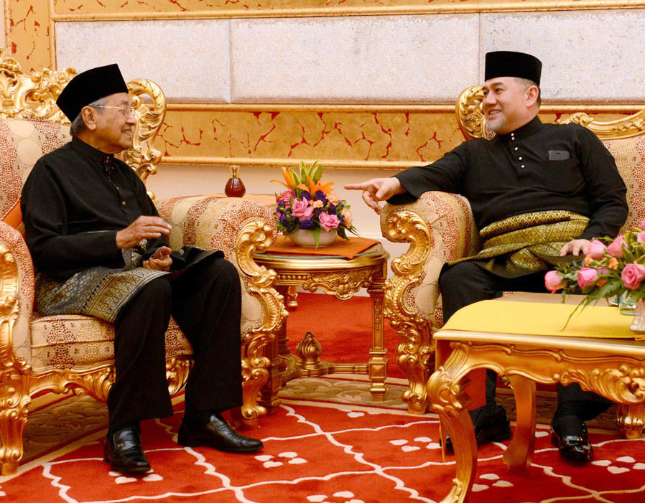

Malaysia election 2018

Election of Prime Minister

Politics of Malaysia takes place in the framework of a federal representative democratic constitutional monarchy in which the Yang di-Pertuan Agong is head of state and the prime minister of Malaysia is the head of government .Executive power is exercised by the federal government and the 13state governments.

Role

Introduction